CR002

Case Linking

**Contents**

1 Introduction 3

2 Case Linking Design 4

2.1 Detail 4

2.1.1 Receive Dispute API 4

2.1.2 Dispute Triage – Validation Rules 4

2.1.3 Case Facts 4

2.1.4 Linked Cases Form 5

2.1.5 Customer and Case Locking 5

2.1.6 Case Actioning – All Types 6

2.1.7 Complete Case 7

2.1.8 Suppliers 7

2.1.9 Data Services 7

2.1.10 Stash Data Model 7

2.1.11 Dispute API 8

3 Impact 9

3.1 Delivery Schedule 9

3.2 Resource 9

3.3 Infrastructure 9

3.4 Licensing 9

3.5 Services Cost 9

**Amendment History**

|  |  |  |  |
| --- | --- | --- | --- |
| **Revision** | **Date Issued** | **Author** | **Reason for Change / Description** |
| V0.1 |  | Andrew Simmers | Initial draft |
| V0.2 |  | Andrew Simmers | Updates following internal review |
| V0.3 |  | John Webb | Added changes to the supplier portal required |
|  |  |  |  |
|  |  |  |  |

# Introduction

The current numero interactive design groups disputes for the same reason against an individual credit report item into a single numero dispute case. This allows consumers to raise disputes from, and receive dispute updates to, different sources (Noddle, Reseller and Manual) that only need to be actioned once in numero interactive.

However, there is no provision in the design to link cases from the same consumer about different credit report items, or different dispute reasons on the same item, together. This will prove restrictive when an agent wishes to resolve cases together or a supplier wants to respond to several disputes from the same consumer within the one case.

As such, this change details the design and the impact of providing case linking as part of the phase 1 numero interactive Project Optimus delivery.

# Case Linking Design

## Detail

### Receive Dispute API

The Receive Dispute API will be updated to include a case linking rule as per the diagram below.

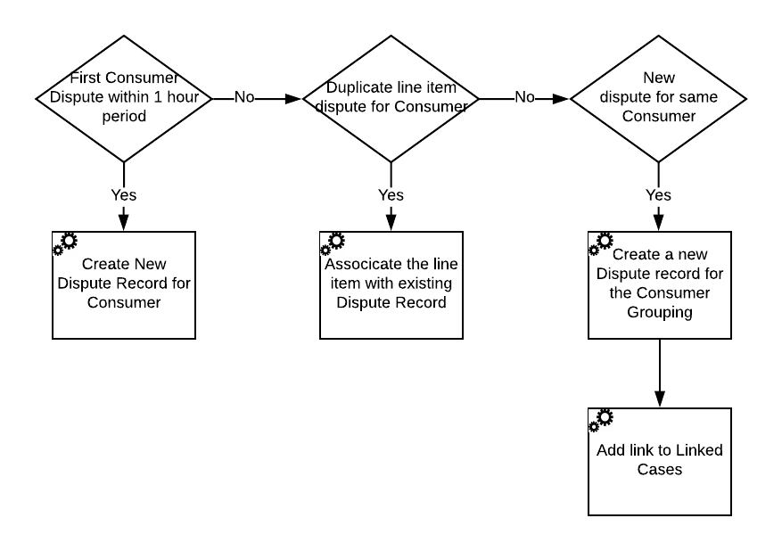

If the rules identify a new dispute for the same consumer the new dispute record is created, and an entry added to the Linked Cases data type to link the case together with the other consumer cases.

The results of the grouping & linking rules are logged in the decision data for that case.

All linked cases are submitted to numero interactive once the timer expires on the 1st case.

### Dispute Triage – Validation Rules

The Dispute Triage validation rules will be updated to include the following rule:

|  |  |
| --- | --- |
| Rule | Details |
| Linked cases | If the dispute case is part of a linked case grouping the case is routed for manual processing. |

All linked cases must be routed for manual processing to ensure the cases are treated consistently.

The results of the validation rules are logged in the decision data for that case.

### Case Facts

The following case fact will be added and presented on the case home form where appropriate:

1. Linked cases present.

### Linked Cases Form

The linked cases form is accessed from the case home form displaying details of the linked cases and adding/removing case links.

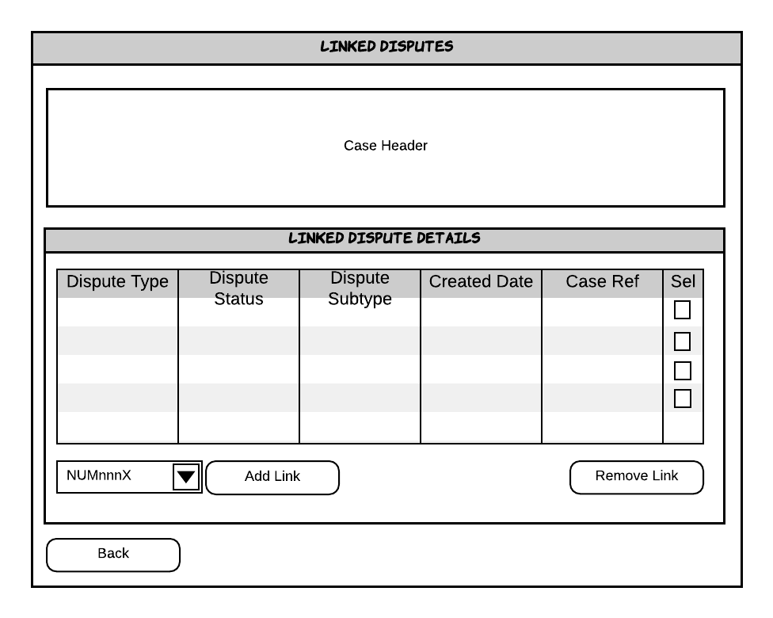

**Remove Link**

Links are removed by selecting one or many linked cases in the table and pressing the ‘Remove Link’ button. This removes the case from the Linked Cases and allows the case to be processed individually.

**Add Link**

Case links can be created by selecting the numero case reference from the drop-down field and clicking the ‘Add Link’ button.

Links can only be added to cases that are threaded to the same numero customer record. The link is added to the Linked Cases group within stash.

To view the details on a linked case the agent must open the corresponding actionable workitem. The latest actionable workitem within the linked case can be opened by clicking on the relevant row in the linked cases table.

**Note:** It is only possible to add and remove links when the case is at the Dispute Investigation stage.

**Note:** Links cannot be removed once the case has been set as ‘resolved with another’.

### Customer and Case Locking

numero Interactive’s customer locking and case locking features will be enabled. When a workitem is popped to an agent no other active workitems from any cases threaded to the numero customer record will be popped to other agents. This ensures that any linked (and potentially non-linked) cases can be reviewed and consistently handled by a single agent.

### Case Actioning – All Types

Where a case is marked as a linked child case an additional decision will be required as part of the all types case actioning.

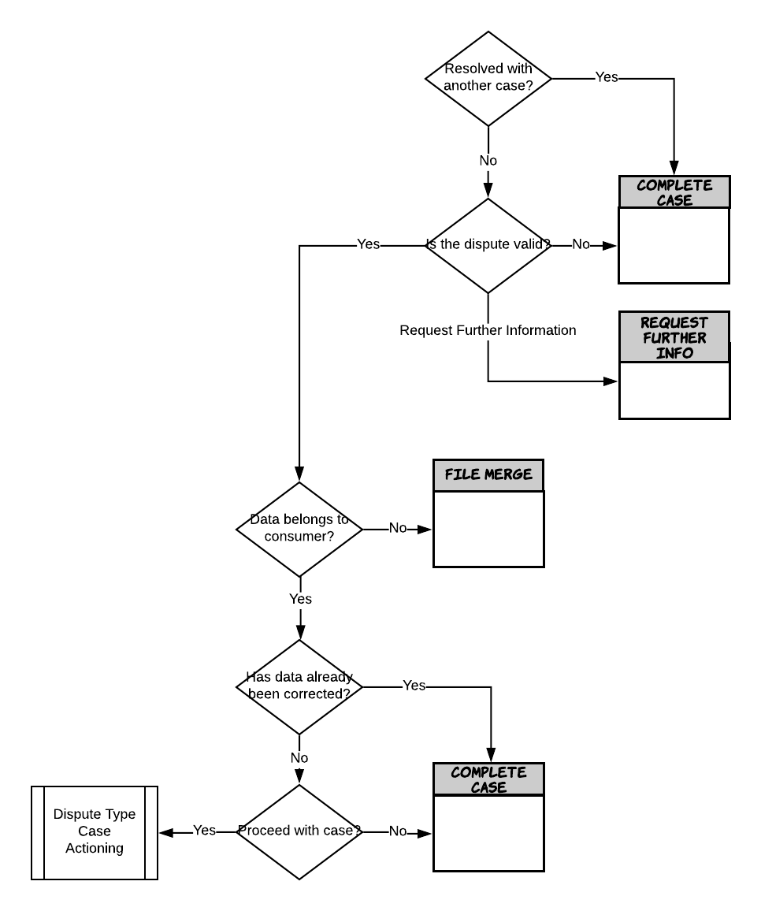

If the advisor selects the case is resolved by another case they are routed to the complete case screen with the status set to Rejected with a reason of ‘Resolves with another case’.

**Note:** It is not possible to reverse this decision. The agent will be presented with a warning before resolving the case.

All case actioning is executed within the case home form for that case. An agent must open the corresponding actionable workitem to process the case.

When a case is marked as resolved by another the linked case status must also be updated. Once there is only 1 active case in the group it is not possible to select this case is resolved by another and the case must be processed appropriately.

**Note:** Resolved with another must only be used when a single action can resolve all cases, e.g. File Merge. It must not be used to group multiple actions into a single case. This is future proof the system for further automated processes to be delivered in other project phases.

**Note:** NoDs for cases marked as resolved by another are not removed until the parent case has been resolved.

**Note:** Noddle notifications for cases marked as resolved by another are only sent when the parent case reaches the appropriate case stages.

**Note:** The consumer receives a single piece of correspondence to cover all cases marked as resolved by another.

### Complete Case

When a case is set to ‘Rejected’ with a reason of ‘Resolves with another’ the agent must be able capture the case reference of the case it is resolved with.

The agent will be presented with a drop down containing the references of the cases the case is linked with populated from the Linked Cases type.

### Supplier Portal

Where linked cases need to be sent to a supplier or suppliers the agent must process each case individually to ensure the appropriate supplier request records are created for each case.

When a supplier request is created for a linked case the request will be stamped with the Id of the Linked Cases object. This Id will be used to filter the list of open disputes to show disputes within a linked group only, and to allow all disputes in a linked group to be locked by a user in a single action.

The following wireframes summarise the changes to the Portal Homepage and how the user will be able to filter and lock linked cases.

The following development tasks will be required:

* Portal Homepage
  + Add a new column to the Disputes grid
    - Title - ‘Linked Case?’
    - Format – image, checkbox or just ‘Yes’
  + Add a new checkbox above the Disputes grid
    - Label – ‘Show linked case’
    - Disabled and unchecked by default
    - Enabled if the selected row in the grid is a linked dispute case
    - When grid selection changes from a dispute in a linked group to one that is not, the checkbox should be unchecked and disabled
    - When checked, only disputes in the same group of linked cases as the selected row will be displayed
    - When unchecked, the filter on the linked case id of the selected row in the grid should be removed
  + Display a new modal dialog when a user opens a linked dispute case to check whether the user wants to lock all linked disputes or just the selected one
    - dialog not required if the currently selected dispute is the last open dispute in the linked group
    - No – single dispute is locked and displayed as per a normal, unlinked dispute
    - Yes – all open disputes linked to the selected dispute are locked and selected dispute is displayed
* Dispute Details Page
  + The behaviour when the user closes this page (any action) should be modified to reapply the linked case filter to the disputes grid on the homepage if the page was opened after locking all items in a linked case group

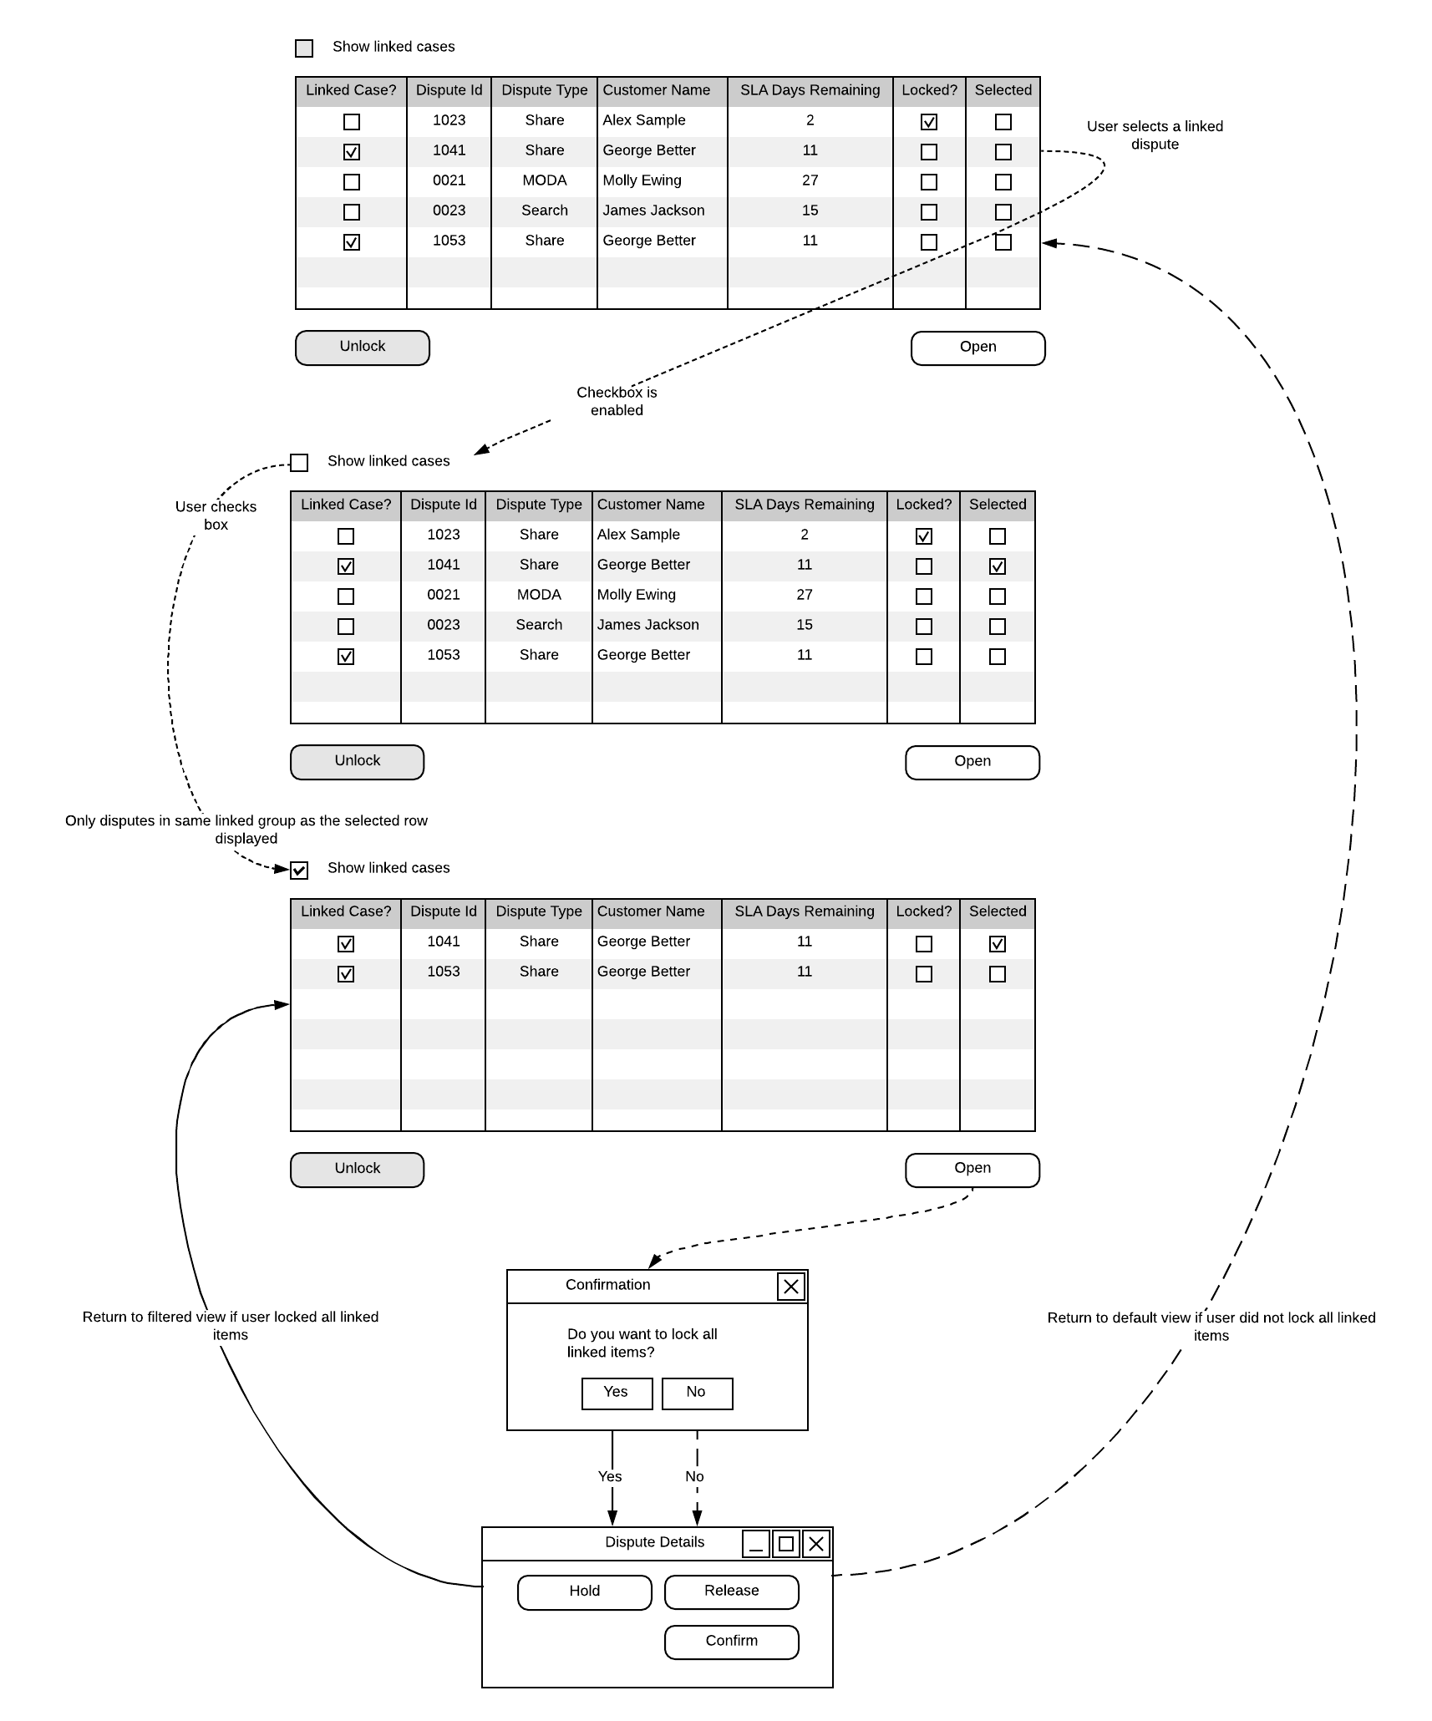

### Data Services

Data Services will only receive a single request to affect a data update for cases that have been linked as marked as resolved by another case.

For linked cases not resolved by another Data Services will receive a request per case where a data update is required. Customer locking will ensure data update workitems are not popped to multiple agents allowing a single agent to request all the updates required for a single consumer.

### Stash Data Model

#### linkedcases

A new stash data type, ‘Linked Cases’ will be created. Each object in this type will define a group of linked cases and will include the status of each case in the group.

* Id - integer
* Linked Case - array
  + caseId - integer
  + linkedCaseStatus - string

#### disputecase

The Dispute Case data type will be extended with a new, top-level attribute to indicate if the case is part of a linked group.

* isLinkedCase – Boolean

#### supplierrequests

This type will be extended with a new attribute to identify that the dispute is part of a group of linked cases.

* LinkedCasesId - integer

### APIs

#### Dispute

The following endpoints will be added to the Dispute API.

* POST /LinkedCases
* PUT /LinkedCases/{linkedCaseId}
* GET /LinkedCases
* GET /LinkedCases/{linkedCaseId}

#### Suppliers

The following endpoint will be added to the Suppliers API.

* POST:/supplierrequests/linkedcases/{linkedCaseId}/Lock

#### Shared Code

All code objects used to represent the Dispute Case and Supplier Request types must be updated to include the new attributes added to Stash.

# Impact

## Delivery Schedule

## Resource

|  |  |
| --- | --- |
| Description of work | Effort (days) |
| Build   * Grouping rules * Validation rules * Data model * Dispute API * Agent flows application * Supplier portal   Unit testing | 30 |
| Project Management | 3 |

**Note:** It is assumed this requirement is tested (SIT, UAT) and released as part of the phase 1 Project Optimus delivery.

## Infrastructure

There are no numero interactive infrastructure implications.

## Licensing

There are no numero interactive licensing implications.

## Services Cost